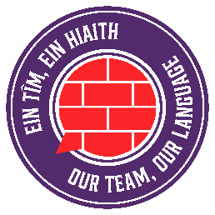
C’mon Cymru!
Pêl-droed | Football
Cwpan y Byd | World Cup
Gêm/gemau | Game/games
Cicio | Kick
Gôl | Goal
Sgorio | Score
Peniad | Header
Y Wal Goch | The Red Wall
Cic o’r smotyn | Penalty
Cic gornel | Corner kick
Cic rydd | Free kick
Sgôr/sgôr derfynol | Score/final score
Camsefyll | Offside
Amser ychwanegol | Extra time
Cerdyn melyn/coch | Yellow/red card
Capten | Captain
Rheolwr | Manager
Dyfarnwr | Referee
Blaenwr | Forward
Asgell | Wing
Ymosodwr | Attacker
Chwaraewr canol cae | Mid-field player
Amddiffynnwr | Defender
Gôl geidwad | Goalkeeper
Anaf | Injury
Hanner amser | Half time
Cefn y rhwyd | Back of the net
Tafliad | Throw in
Rownd yr wyth olaf | Quarter Final
Rownd gynderfynol | Semi-final
Rownd derfynol | Final
Dathlu | To celebrate

