Weekend course for young people Draft Timetable
11-13 July 2025, Carmarthen Campus, University of Wales Trinity Saint David
Friday Night
When? | What? | Where?
5pm-6pm | Arrive, register and settle in | Halliwell Restaraunt + accomidation block
6pm | Welcome Meating | Halliwell Restaraunt
6:15pm | Class 1 | Room 1/2/3
7pm | Dinner | Halliwell Restaraunt
8pm | Board Game Night | Room with bar

Saturday
When? | What? | Where?
9am - 9:30am | Breakfast | Halliwell Restaraunt
9:45am | Class 2 | Room 1/2/3
11:15am | Coffee | Halliwell Restaraunt
11:45am | Workshop 1: Team building activity | Room A
1pm | Lunch | Lunch box
2pm | Workshop 2: Visit the Egin (S4C) | The Egin
4pm onwards | Gŵyl Canol Dre  Walk to the festival with tutors 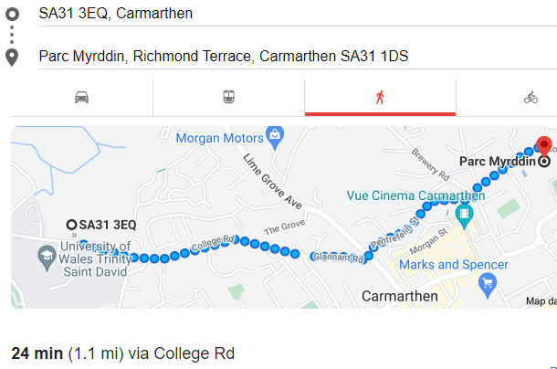 | Myrddin Park, Carmarthen

Sunday
When? | What? | Where?
9am–9:30am | Breakfast | Halliwell Restaraunt
9:45am | Class 3 | Room 1/2/3
11am | Coffee | Halliwell Restaraunt
11:30am | Option 1: Puppet Workshop | Room 1/2/3
12:30pm | Lunch and goodbyes | Halliwell Restaraunt

