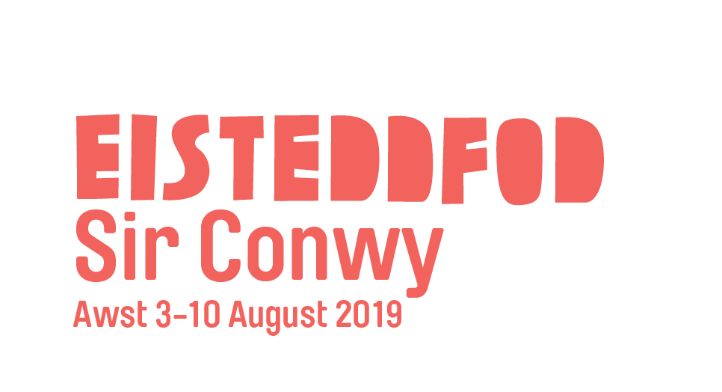
Ffurflen Gais: Tlws Coffa Elvet a Mair Elvet Thomas
Application Form: Elvet Thomas and Mair Elvet Thomas Memorial Trophy
Cefndir: Roedd Elvet Thomas yn ddyn arbennig iawn. Fel athro yn Ysgol Cathyas, ysbrydolodd genedlaethau o ddisgyblion, y mwyafrif o gartrefi di-Gymraeg, i ddysgu’r iaith yn rhugl. Sefydlodd Adran o'r Urdd yn yr ysgol yn y 1920au, ac fe daflodd ei hun i mewn i holl weithgareddau'r mudiad yn y cyfnod cynhyrfus hwnnw. Rhoddir y wobr hon er cof amdano a’i wraig i diwtor Cymraeg sydd yn neu wedi gwneud cyfraniad nodedig i faes Cymraeg i Oedolion. Rhoddir y wobr gan Rhiannon Gregory. Cyflwynir y Tlws ym mhabell y dysgwyr, Shw’mae Su’mae, Eisteddfod Genedlaethol Sir Conwy, ddydd Sadwrn 3 Awst a gofynnir i’r enillydd fod yn bresennol
Background: Elvet Thomas was a special man. As a teacher in Ysgol Cathays, he inspired generations of students, the majority from non-Welsh speaking homes, to learn the language fluently. He established an Urdd group in the school in the 1920s, and he threw himself fully into all of the organisation’s activities during that exciting time. This prize is awarded in his and his wife’s memory to a Welsh tutor for making a notable contribution to Welsh for Adults. The prize is donated by Rhiannon Gregory and will be presented in the learners’ pavilion, Shw’mae Su’mae at the Conwy National Eisteddfod on Saturday 3rd August. The winner will need to be present to accept the prize.
Manylion yr enwebai / Nominee’s information
Enw / Name …………………………….. E-bost / Email………………………………………
Cyfeiriad / Address ……………………………………………………………………………………… ……………………………………………………………………………………………………………….
Rhif(au) ffôn / Phone Number(s) ……………………………………………………………………..
Manylion yr enwebydd / Details of nominator
Enw / Name ……………………………… E-bost / Email ……………………………………………
Cyfeiriad / Address ……………………………………………………………………………………… ……………………………………………………………………………………………………………….
Rhif(au) ffôn / Phone number(s) ………………………………………………………………………
Nodwch wybodaeth gyffredinol (tua 1 dudalen A4) / Please note general information (about 1 page A4)
- Pam rydych yn enwebu’r person hwn? / Why are you nominating this person?
- Beth sy’n arbennig am y person? / What’s special about the person?
- Sut mae wedi ysbrydoli dysgwyr a/neu diwtoriaid eraill? / How have they inspired learners and/or other tutors?
- Nodwch 3 gair i’w (d)disgrifio / Note 3 words which describe them
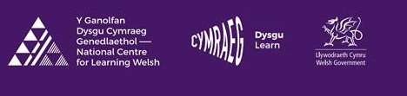Anfonwch eich ffurflen at / Send your form to: Swyddog Hyrwyddo’r Gymraeg, Uned 15, Parc Busnes yr Wyddgrug, Yr Wyddgrug, CH7 1XP / neu cathryn@eisteddfod.org.uk DYDDIAD CAU / CLOSING DATE: 1/7/2019
Cyn enillwyr Tlws Coffa Elvet a Mair Elvet Thomas

Llanelli 2000 Chris Rees
Dinbych 2001 Basil Davies
Tyddewi 2002 Felicity Roberts
Meifod 2003 Robina Ellis-Gruffydd
Casnewydd 2004 Geraint Wilson-Price
Y Faenol 2005 Elwyn Hughes
Abertawe 2006 Elwyn Havard a Keith Rogers
Sir Fflint 2007 Eirian Wyn Conlon
Caerdydd 2008 Cennard Davies
Y Bala 2009 Shirley Williams
Glyn Ebwy 2010 Ken Kane
Wrecsam 2011 Gwilym Roberts
Ynys Môn 2017 June Parry
Caerdydd 2018 Helen Williams

